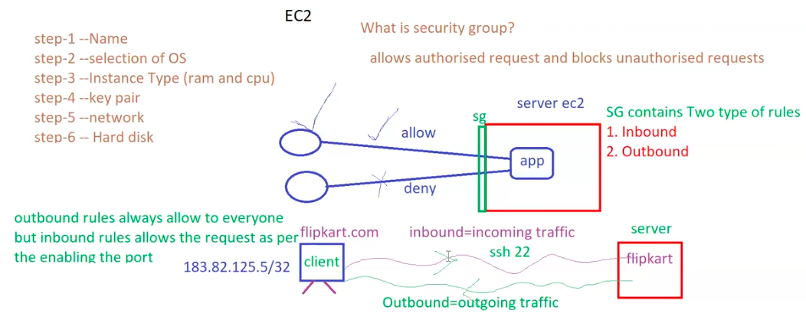

What is security group?

It allows authorized request and blocks unauthorized requests.

Security groups works under EC2 level.

SG contains 2 types of rules.

1. In bound (incoming traffic to server (EC2)).

2. Out bound (Outgoing traffic).

* EBS –as hard disk in AWS.
* SSH to connect server (Devops and Developers)
* http and https for access the page.